**Documentation Requirements**

Requirements

We created an application that stimulates an airline reservation system. The application should launch initially with a splash screen that transitions into the main page. The airline reservation system requires the main menu. On the main menu, the user should have the option to log in (if they already have an account) or register for an account.If they choose to register, a registration form should appear. When registering, it’s required that the user enters a first name, last name, address, zip code, state, username, password, email, social security number, security question, and security answer. If a user knows their username and the answer to their security question, the user should be able to retrieve their password. Once a customer is logged in, they should have the option to logout of their account. There are 2 types of users: customers and admin. When an admin logs into the application, they should have all of the privileges of a customer account and be able to add, alter, and delete flights. All users should have the option to go back to the main menu while using the application. The customer can search for flights and book and delete flights from his or her account. While logged in, customers should have the ability to search for flights by time, origin city, destination city, and time of flight. The application will ensure a customer can not book a flight if the flight is full. When the customer logs out of their account, and logs back in, the customers previously booked flights should still be in their account.

Class Diagram

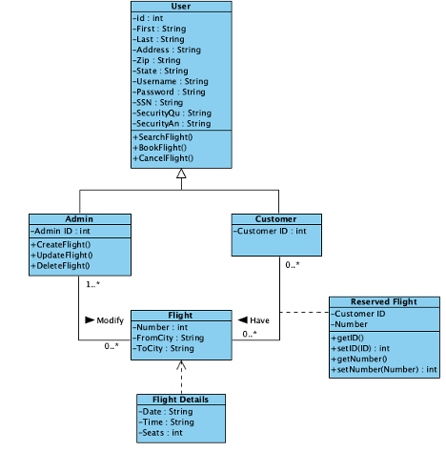

Data Model

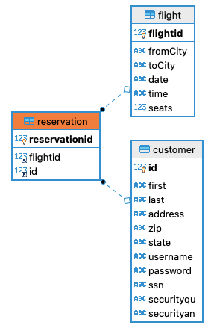

Flow of Program

We began with the splash screen and created a file called splash.fxml using SceneBuilder to design the interface. Then, we created the controller class for the splash.fxml that handles the transition method. This method is located in the FadeTransition class. This allows the splash screen to fade out and fade in to the login page.

In the next part, we created the login.fxml file using the SceneBuilder again. The left side of the scene contains login information (username and password) for users with an account and the right side of the scene contains registration for new users.The controller class for this file is called LoginController, which initializes the UI elements in the fxml file.

The javaAppCIS file class is where the program runs. The mainMenu() method is the beginning of the program. The main menu contains a button for login and a button for registration. There is also a button for “forgot password”. We used the setStyle() to set the colors of the buttons. The layout type we used is vbox.

Now for clicking the buttons; clicking the login button initiates the loginPage() method. On the login window (stage) there is a label for username and text field to enter username and a password label and password field to enter your password. There are 2 buttons at the bottom: back and login. The back button returns to the main menu and the login button brings you to the reservation page. The registration page comes from the registrationPage() method. It contains the text fields: Flying from, Flying to, Trip starts on, Trip ends on, Number of passengers, and Time preference. There is a button to reserve the flight and a button “back” to return to the main menu.